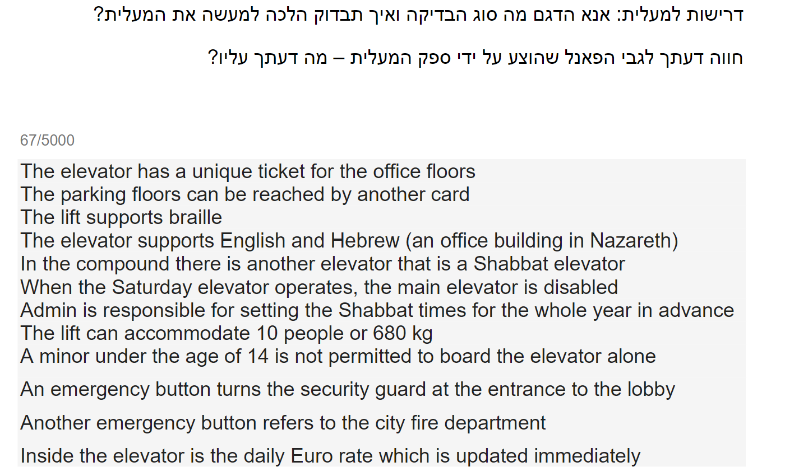

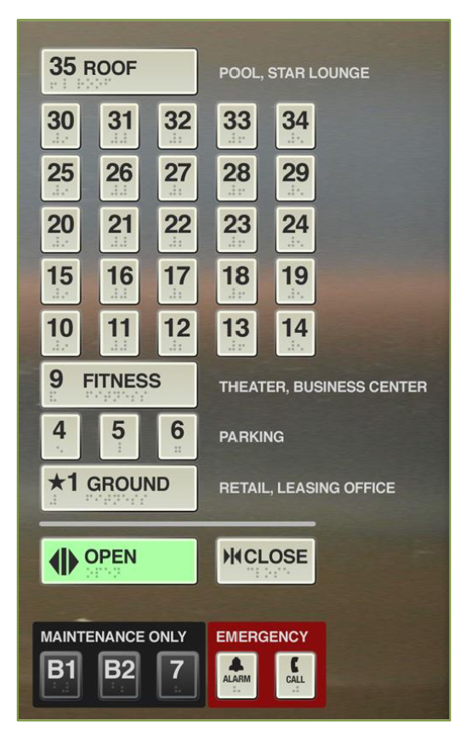

**Functionality testing:**

* I will check that the elevators inside and outside buttons are working correctly.
* I will check that the elevator can reach every floor of the building from the top floor down, and from the bottom floor up.
* I will check that I’m able to reach the office floor using the dedicated card for the office floors.
* I will check how the system behaves if I try to reach the office floors using a different card. I suggest an error on the screen in the lines of: “Access denied, please scan the correct card”.
* I will check how the system behaves if I try to reach the office floors without a card. I suggest an error on the screen in the lines of: “Access denied, please scan the correct card”.
* Question - how does the card operate? Do I scan it before entering the elevator? Do I scan it inside the elevator before pressing the buttons? Does the card have an expiration date? It’s not clear from the documentation.
* I will check if I’m able to reach the parking floors using the dedicated card for the parking floors.
* I will check how the system behaves if I try to reach the parking floors using a different card. I suggest an error on the screen in the lines of: “Access denied, please scan the correct card”.
* I will check how the system behaves if I try to reach the parking floors without a card. I suggest an error on the screen in the lines of: “Access denied, please scan the correct card”.
* I will check that the braille writing is displayed correctly under each element inside and outside the elevator.
* I will check that the Hebrew and English language support appears correctly. Q - it’s not clear from the documentation if the language support is only in writing or also in a form of a voice-over. In the case of a voice-over system, I will check that both languages are being heard correctly and are corresponding to the action of the user and the state of the elevator.
* I will check if the Shabbat elevator works on Saturday.
* I will check the behavior of the Shabbat elevator on the other days of the week.
* I will check if the main elevator works on Saturday.
* I will check if an Admin can access the system of the Shabbat elevator and make changes to the Shabbat times.
* I will check what is the behavior of the system if I try to access the Shabbat times with a different user that is not Admin.
* I will test if the lift can accommodate 10 people going up and going down.
* I will test if the lift can hold 680 kg going up and going down.
* I will perform boundary value testing and check the behavior of the elevator with 681 kg going up and going down.

I will suggest that an alarm will be displayed and heard (in all supported languages), saying that the maximum weight capacity has been reached. I also suggest that the doors should not close when the elevator is overloaded.

* I will check the behavior of the system with 11 people going up and going down.
* I will perform boundary value testing and
* I will check that there is a sign in all supported languages with a warning along the lines of: “Minors under the age of 14 are not allowed inside the elevator without the presence of an adult”. Q - Is there another way for the system to prevent the use of the elevator by minors under 14 that are alone?
* I will check if the emergency button calls the security guard.
* I will check that the second emergency button reaches the fire department.
* I will test the euro rate system inside the elevator and check if it corresponds to the real and updated euro rates in real-time.
* I will check if the euro rate system supports both Hebrew and English.
* I will check how long it takes for the elevator doors to close automatically.
* I will check the behavior of the system if I press multiple floor buttons.
* I will check the behavior of the system when the elevator is called while in use. Will it make a stop or finish the first ride?

**Security testing:**

* I will check the behavior of the system if I create fire or smoke inside the elevator. I suggest a smoke detection system that will activate the emergency buttons automatically.
* I will check the behavior of the system when the “open” button is pressed while the elevator is moving.
* I will check the behavior of the system when I put a small obstacle between the doors of the elevator. Will the sensors work and stop the doors from closing?
* I will check that the emergency buttons react in a reasonable time frame.

**Survival & Recovery testing:**

* I will check the behavior of the system in a power failure - Will it stop on the spot? Will it stop at the nearest floor? Will it go to ground level? Will the doors open in case the elevator stopped on a floor? There should be a backup mechanism that will prevent the elevator to be stuck between floors
* I will check the behavior of the emergency buttons during power failure
* I will check the behavior of the system when the power is back on - will it continue with her original program or do we need to press the floor button again manually?

**Performance testing:**

* I will check how long it takes for the elevator to reach the top floor from the ground floor and vice versa, with and without load?
* I will check how long it takes for the elevator to reach the top floor from the ground floor and vice versa, with and without maximum load and maximum capacity?
* I will check how long does it take for the elevator to reach the nearest floor, with load, without load, and with maximum capacity load?
* I will check how long it takes for the elevator doors to close and the ride to start from the moment I selected the floor.
* I will check the response time of the elevator from the moment it was called.

**Load and stress testing:**

* I will test the behavior of the system with an increasing load to check for the system’s breaking point
* I will check the behavior of the system with an increasing load, going up and going down
* I will check the behavior of the system while operating nonstop for a long period of time, searching for a breaking point

**Maintainability testing:**

* I will check the flexibility of the code - will it be able to accommodate future changes like adding more floors to the building or adding voice activation in the future?

**Usability testing:**

* I will check if the functionalities of the elevator are self-explanatory? Is the use of the elevator easy and intuitive for all age groups?
* I will check if there are correct and easy-to-understand signs in Hebrew and English explaining what to do in case of an emergency with correct phone numbers?

**Accessibility testing:**

* I will check that the elevator meets the accessibility standards of the accessibility law in the country.
* I will test if all the buttons are reachable to a person seated in a wheelchair?
* I will check the braille writing on all the buttons and emergency signs
* I will check if there is voice over for the elevators buttons and actions, for the visually impaired individuals
* I will check if the entrance of the elevator is accommodated for handicapped people in a wheelchair
* I will check that the elevator is stopping on the floor level and not above or below - so there won’t be “steps” and the entrance should be clear and straight
* I will check if there are handles inside the elevator, to be used in case of an emergency
* I will check if the outside door has a handle that can be easily used by disabled or old people
* I will check if there are sound alerts when doors are being closed and open and when reaching a certain floor

**Gui testing:**

* I will check that the inside and outside of the elevator correspond to the documentation and that the colors, fonts, signs, flooring, and overall look is as specified.

**Suggestions and improvements:**

* I suggest adding Arabic as another language. The elevator is located in a city with a majority of Arabic speaking population.
* The elevator panel is missing floor buttons: 2,3,7,8
* I suggest changing the ground floor to 0, it’s more intuitive and user friendly
* I suggest adding Hebrew and Arabic to the writing on the panel
* I suggest narrowing down the number of lines of buttons in the panel and putting more numbers on the same row, to make it wider. Too many lines will make the panel longer and more difficult to reach by handicapped people in wheelchairs.
* It’s not clear from the documentation and the pane where should I place the cards for the office and parking floors - is it on the buttons or should there be a specific screen?
* There is no braille writing on the “maintenance only” and “emergency” lines.
* There should be a stop button to be used in case of an emergency.